Agate

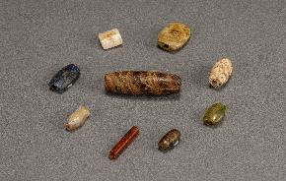

Beads — Carnelian, Granite, Lapiz lazuli, Agate; Findspot: Mohenjo-daro, Pakistan; 2600–1900 BCE; CSMVS (IV 1513, 628, 629, 651, 656, 654, 1490, 1486, 1489)

